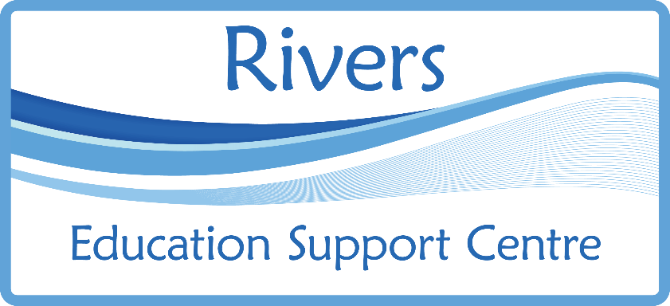
DSPL3
Primary
Behaviour Team
Rivers Education Support Centre provides a targeted and specialist primary behaviour service in DSPL3, for primary aged pupils with high level of social emotional and mental health needs (SEMH).
This includes:
• Outreach support for schools and individual pupils with SEMH, high needs.

• Intervention for pupils at risk of suspension and permanent exclusion.

• Provision of tuition from the 6th day of permanent exclusion, in a mainstream school.
- Family support to develop routines and boundaries at home, as well as signposting to other agencies, through the Local Offer.

This service will:

• Work in partnership with staff in local Primary Schools to model approaches, offer strategies and support staff to create personalised resources for individual pupils and small groups.
• Provide bespoke interventions to pupils and small groups.
• Work with school staff to identify individual pupils' needs and develop a graduated response.
• Work in partnership with school staff and parents/carers to create personalised support agreements, to meet the needs of pupils with SEMH.
• Offer bespoke support for school staff, e.g. understanding individual pupil behaviour, whole class and individual pupil strategies and solution focused meetings.

If you need support, please ring the Telephone Helpline: 01992 534841

What does support from the DSPL3 Primary Behaviour Team look like?
The team manager will carry out an Audit of Need, with the SENCo
Personalised support agreements can consist of the following forms of support from the team’s teachers:
• Individual pupil observations and assessments of needs, followed by discussions with the teacher, SENCo and/or senior staff.
• Support with developing a positive behaviour policy and inclusive practices.
• Support to create Therapeutic - Risk Reduction Plans and embedding Therapeutic Thinking into practice.
• Whole class observations and support for teachers. Facilitate Solution Focussed meetings.
• Interventions for pupils with the highest needs.
• Plan and deliver support for schools for pupils undergoing Managed Moves.
Support from the team’s outreach support staff:
• Individual pupil interventions: emotional literacy, Protective Behaviours, social skills, learning behaviours and resilience.
• In class, individual and small group support.
• Family support.
• In class support to model strategies.
• LSA/MSA peer mentoring
A meeting with the SENCo or Head teacher and the pupil’s parents, to create a personalised support agreement

Please send this form password protected, with the password in a separate email.

This form is available to download from Rivers ESC website:
www.riversesc.herts.sch.uk
Request for support form:
School Name: | Click or tap here to enter text.
School contact: | Click or tap here to enter text.
Pupil name: | Click or tap here to enter text.
Date of Birth: | Click or tap here to enter text.
Year Group: | Choose an item.
What are the pupil’s social, emotional and mental health needs?
Click or tap here to enter text.

We confirm that a referral to the DPSL3 Primary Behaviour Team has been discussed with parents/carers, who have given consent to the service being received.
Parent:Click or tap here to enter text. | Signature:Click or tap here to enter text. | Click or tap to enter a date.
School:Click or tap here to enter text. | SignatureClick or tap here to enter text. | Click or tap to enter a date.

