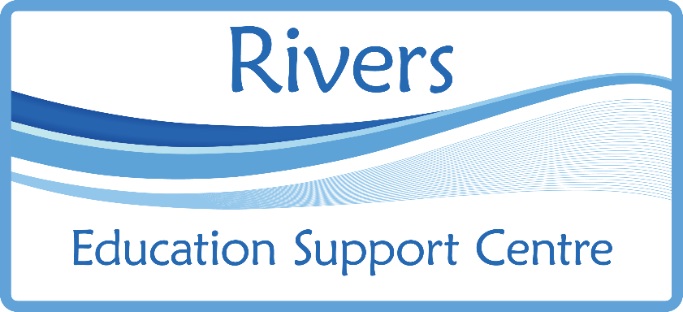
Primary
Behaviour Team
Rivers educational support centre provides a targeted and specialist primary behaviour service in DSPL3 for primary aged pupils with high level social emotional and mental health needs (SEMH).
This includes:
• Outreach support for schools and individual pupils with SEMH high needs.

• Intervention for pupils at risk of permanent exclusion.

• Provision of tuition from 6th day of permanent exclusion in a mainstream school.

This service will:

• Work in partnership with staff in local primary schools to model approaches, strategies and use resources for individual pupils and groups of pupils.

• Work directly with pupils 1:1 or in small groups class.

• Work with the school to identify individual pupils' needs and develop a graduated response.

• Work in partnership with school staff and parents/carers to create personalised support agreements to meet the needs of pupils with SEMH, who are at risk of permanent exclusion.

• Offer training sessions for staff. (for example: solution focused approaches, classroom strategies, circle time, emotional literacy, attachment, social skills).

• Facilitate half termly network meetings for staff working with pupils in receipt of ENF funding for SEMH.

If you need support, please ring the Telephone Helpline: 01992 534841

What does support from DSPL3 Primary Behaviour Team look like?
A team coordinator will visit to carry out an audit of need with school staff.
Set up a meeting with the Head Teacher. A personalised support agreement will be created.

Personalised support agreements can consist of any of the following forms of support from the team’s teachers:
• Individual pupil observations and assessments followed by discussions with teacher, LSA, SENCo and/or senior staff.
• Support with developing a positive behaviour policy and inclusive practices.
• Support to create risk reduction plans and embedding Hertfordshire Steps into practice.
• Support with EHCP, ENF and attendance at professionals meetings.
• Team teaching with class teachers and solution focussed meetings.
• Interventions for pupils with the highest needs.
• Plan and deliver support for schools and pupils with managed moves.
Support from the team’s outreach workers:
• Individual pupil interventions: Emotional literacy, social skills, learning behaviours and resilience.
• In class, small group support.
• Family support.
• In class support to model strategies.
• LSA/MSA peer mentoring
Please send this form password protected, and send password in a separate email.

This form is available to download from Rivers ESC website:
www.riversesc.herts.sch.uk
Request for support form:
School name:
School contact:
Pupil name:
Date of Birth:
Year Group:
What are the pupils social, emotional and mental health needs?

We confirm that access to the DPSL3 Primary Behaviour Team has been discussed with parents/carers, who have given consent to the service being received.
Parent: | Signature: Date:
School: | Signature: Date:

